

Foundations of Programming

Lab Assignment No. : 03

PROBLEM STATEMENT:
Write a program in C to generate multiplication tables for a given number.
OBJECTIVES:
- To understand the use of looping statements in C.
- To generate multiplication tables using loops.
- To improve program logic and execution flow understanding.
THEORY:
- Syntax for for loop example program

Definition
The for loop is an entry-controlled loop in which the condition is checked before the execution of the loop body. It is generally used when the number of iterations is known in advance.
Structure of for Loop
The for loop consists of three expressions:
- Initialization – initializes the loop control variable
- Condition – tests whether the loop should continue
- Increment/Decrement – updates the loop variable after each iteration
All three are written in a single line, making the loop compact and readable.
Syntax
for (initialization; condition; increment/decrement) {
statements;
}

- Syntax for while loop example program

Definition

The while loop is an entry-controlled loop in which the condition is evaluated before executing the loop body. It is used when the number of repetitions is not known beforehand and depends on a condition.

Syntax
while (condition) {
statements;
}

- Syntax for do while loop example program

Definition:

The do–while loop is an exit-controlled loop in which the loop body is executed at least once, irrespective of whether the condition is true or false.

Syntax:

do {
statements;
} while (condition);

ALGORITHM:
- Start
- Declare variables n, i, r.
- Ask the user to enter a number and store in ‘n’.
- Initialise loop counter : i = 1
- Check condition is I <= 10?
If yes go tostep6
Else go to step 9
- Compute multiplication
Multiply n with i and store in r
- Display n *i = r.
- Increment loop counter,
- i = i + 1;
go back to step 5
- stop
FLOWCHART:
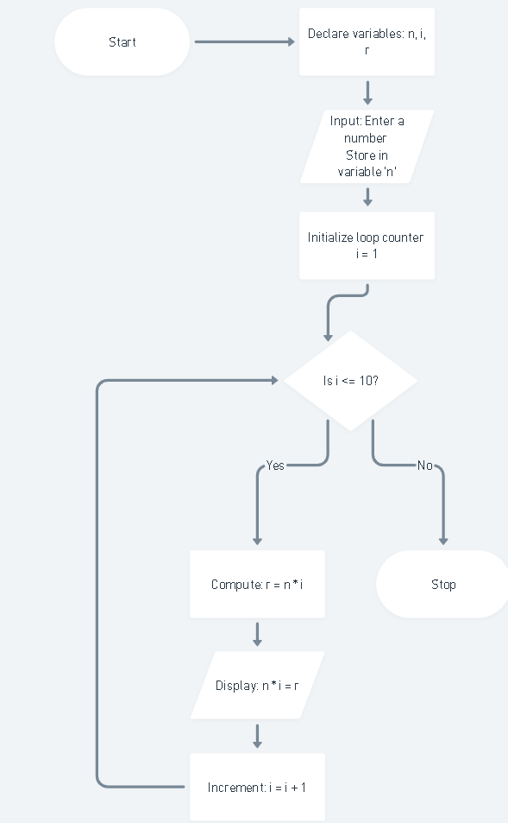
PLATFORM:
Linux
INPUT/ OUTPUT: 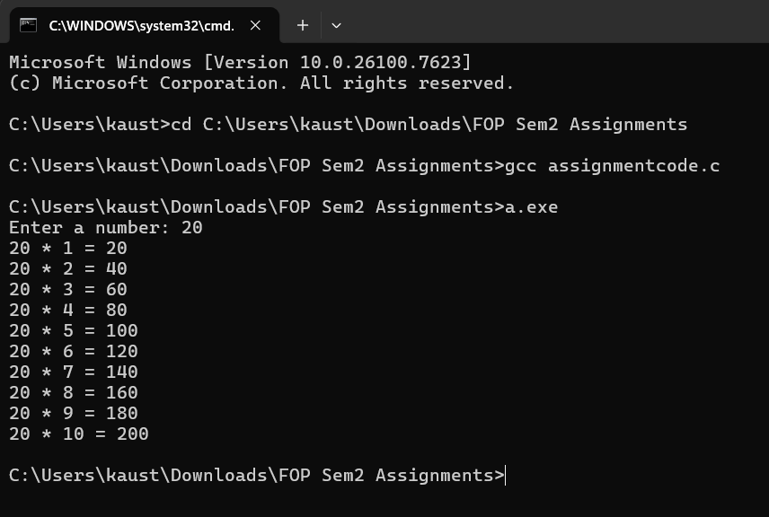
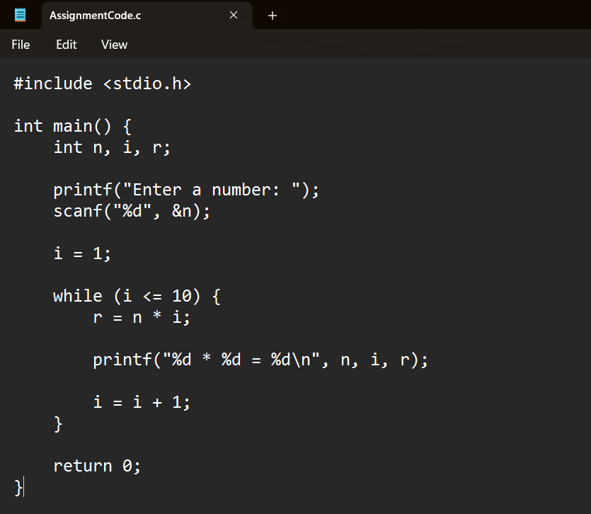
CONCLUSION:
Thus, the menu driven program in C successfully performs basic arithmetic operations using switch–case statements.

